**Welcome**

National Disability Services Queensland invited participants from across the disability sector to be part of a series of conversations to begin to explore the sectors readiness for a national disability insurance scheme and to start mapping the work of building capacity in people with a disability, their families, service providers and the broader community. The conversations will run between September and December.

In welcoming the 52 participants to the Service Development and Innovation Hub, Valmae Rose, State Manager of NDS Qld, acknowledged the traditional owners of the land on which the meeting was held. Valmae spoke of the recent endorsement of the Productivity Commission’s report into an NDIS by the Federal Government and said, “There is work to be done and we need to do it together.”

The calling question for the conversation was: “What will it take for our sector to be ready for a NDIS?”

Fiona Anderson, Queensland NDIS Campaign Co-ordinator was invited to give an overview of the campaign and where to from here.

Valmae invited all participants to work together and have deeper conversations around a number of questions with each question divided into six separate sections. Groups of five people were asked to choose the question which most interested them and during the first session to discuss the first three sections and in the second session to address the remaining three sections.

The following responses were collated:

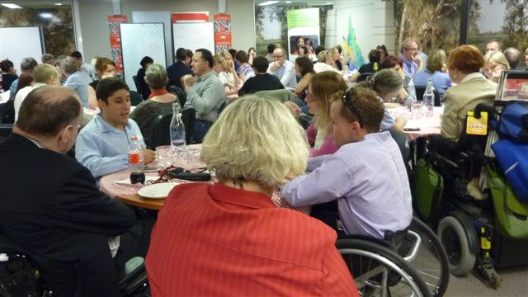

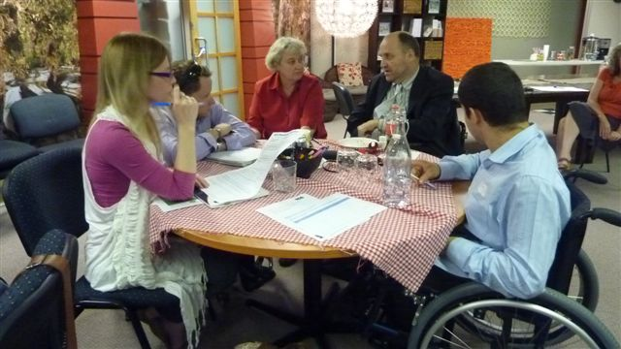

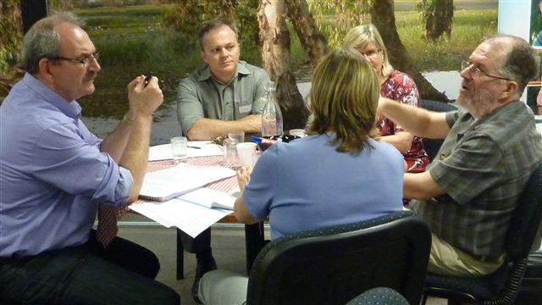

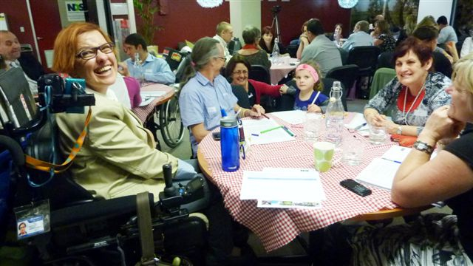

**TOPIC: Person/family as purchaser - (self-managed funds)**

1. **What would this look like in reality?**

* Choice
* Flexibility
* Person centred and individual involved from day 1 and involved in all aspects of process
* Options for brokerage
* Individuals become consumer
* Purchasing different kinds of services (eg, physio, podiatrist)

1. **What are the potential benefits?**

* Personalised and individualised support and lifestyle
* People can envisage and dream of a different future
* People will be viewed with human rights
* Provides flexibility and portability, mix and match as needs change
* Cultural change – People with a disability will be purchasers and employers
* Autonomy – contributing to society and outcomes of own life and self-worth

1. **What are the potential risks?**

* Vulnerable people open for exploitation
* Imbalance of knowledge. Some people may not know what they want and how or where to access service
* Trialling new options may be financially risky if they are not successful
* Lack of understanding by the public as to how funds are spent
* Accountability
* Dynamics of family. Misuse and lack of understanding to build capacity
* Assessment process fails people

1. **What structures/policies/practices need to be in place for it to work well?**

* Clear standards, practices and guidelines
* Register of services
* Community Development focus
* Helpline – 1800 Navigator
* Clear information available
* Time guidelines: assessments, responses, reviews and monitoring
* Safeguards for vulnerable people, keeping dignity of risk
* Policies and practices about valuing people

**TOPIC : Person/family as purchaser - (self-managed funds) continued**

**5. What skills, knowledge, experience need to be strengthened in stakeholders for this to work well?**

* Skills development and education: financial management, brokerage planning and administration, technology
* Need deep and broad knowledge of resources within the local area
* Community navigator
* Cost comparisons
* Good understanding of rights, responsibility and confidentiality
* Skills and qualifications are both valuable
* Ability to share a person’s story in whatever form of communication chosen

**6. Other ideas or perspectives:**

* Learning from experience in Australia and overseas
* Support and develop the non-funding aspects of the community
* How do we remove the layers, barriers?
* Does state government have a role?
* What roles can people with a disability play in the NDIS eg. assessors

**TOPIC: Person-centred service design**

**1. What would this look like in reality?**

* Free flowing and transparent discussions between all stakeholders
* Wants and needs will be met in the most timely and cost effective manner
* Responses would be organic and with the person’s context
* Requires cultural change, active response, inclusiveness and involvement
* Strength based planning
* The person would not be ‘attached’ to the service.
* Resource will be made available to support the life the person wishes to live.

**2. What are the potential benefits?**

* Increase self-esteem, self-worth and reduce family breakdown
* Mainstream integration and acceptance
* Fewer wasted funds
* Improved standards of service providers
* More choice
* No monopoly
* Quality of life guarantee for the person’s whole life even after the family is no longer around

**3. What are the potential risks?**

* Change of circumstance
* Mismanagement of funds
* More control can be overwhelming
* Insufficient workforce
* That it is not truly Person Centred in practice

**4. What structures/policies/practices need to be in place for it to work well?**

* “Person” should always come first
* Clarity around what Person Centred practice is
* Policy around accountabilities
* Customising services
* A single national policy
* A single national complaints body
* Where is the point of decision making around policy and funds allocation
* Access to advocacy
* Redesign social policy
* Flexible relationship between person with a disability and workers
* Embrace whole community
* Human rights and disability policies widely absorbed as well as upheld

**TOPIC: Person-centred service design continued**

**5. What skills, knowledge, experience need to be strengthened in stakeholders for this to work well?**

* Increase knowledge for people with a disability on the rights and where to access advocacy
* Person with a disability training on accountability, reporting and managing staff
* Respect choice.

**6. Other ideas or perspectives:**

* Positive stories should be shared
* Disability sector be aware of jargon language when communicating with the wider community.
* Get “disability” out of disability services

**Topic: Centralised assessment and allocation of funds**

**1. What would this look like in reality?**

* Face to face interviews
* Fair and equitable
* Not crisis driven
* A national scheme
* Uses assistive technologies
* People with disability doing the assessments
* Assessors who are qualified and skilled in different disability types
* Individual to drive review process

**2. What are the potential benefits?**

* Building capacity not dependence
* Valued roles for people with a disability
* More accountability
* Person with a disability in control
* Choice of service providers

**3. What are the potential risks?**

* People fall through the cracks, need to find safeguards
* Compromising people’s dignity
* Unwise choices due to a lack of knowledge
* Misuse of funds by others
* Over quoting

**4. What structures/policies/practices need to be in place for it to work well?**

* Independent appeals
* Guidelines
* Different models for different services
* Work with the community to inform policy
* No penalties for making mistakes
* Look globally for best practice models
* Transparent assessment process and decisions
* Consult and inform the community

**Topic: Centralised assessment and allocation of funds continued**

**5. What skills, knowledge, experience need to be strengthened in stakeholders for this to work well?**

* Experience in investment
* Experience in particular disability
* Communication plan, what is expected? Think outside constraints
* Quoting skills
* Tension between choice and accountability
* Service providers’ skills workshops and forums
* Marketing skills to attract and retain clients

**TOPIC: Investment in community capacity building**

**1. What would this look like in reality?**

* Consultation and planning
* Strategic targeting
* Needs to be responsive and flexible to needs
* Skilled assessors are essential
* What does capacity building mean?

**2. What are the potential benefits?**

* Ability to tailor services and supports.
* Adds personal values
* Ability for people to create their own marketing process
* People feel part of the community
* To better market a united system

**3. What are the potential risks?**

* Not allowing people to make mistakes from which they learn
* Time frames wanting to move too fast
* People developing own perceptions around what community capacity building is

**4. What structures/policies/practices need to be in place for it to work well?**

* Who is responsible?
* Incentives for inclusive practice
* Regulatory bodies should be involved eg. ASIC, Consumer Affairs
* Responsiveness – need to remove layers to increase responsiveness
* Accountability

**5. What skills, knowledge, experience need to be strengthened in stakeholders for this to work well?**

* Information packs – what is a good service provider
* Self–assessment
* Family mediation